English Words without Vowels

In English, the letter 'Y' can be used as a vowel sound.

As a vowel: my (as in “fine”), gym (as in “bin”), yellow (as in “you”)

Here are some English words which use a 'y' as a vowel sound:

Long sound: by, my, dry, fly, fry, cry, shy, sky, spy, try, why
Short sound: gym, hymn, lynx, myth, crypt, gypsy, lynch, pygmy, rhythm, sphynx

The longest English word with no vowels is 'rhythms' (7 letters). There is however, an obsolete word from the 17th-century, 'symphysy', which has 8 letters. There is also an archaic word with 12 letters - 'twyndyllyngs', which means "twins".

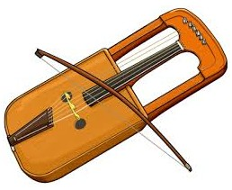
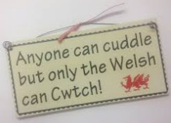

Middle English also used the letter 'W' to represent a vowel sound, particularly during the 14th and 15th centuries. This practice still exists in modern Welsh. For example, a 'crwth' (pronounced 'crooth') is a musical instrument similar to the violin. Also, 'cwtch' (pronounced 'cooch') means ‘emotional embrace’. A 'cwm' (pronounced 'coom') is a valley between mountains.

